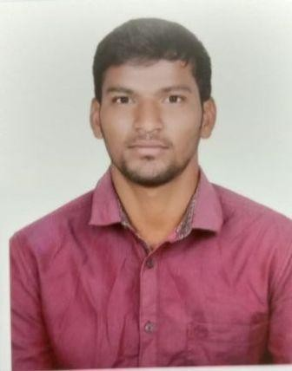Narayana swami .Vallapuneni

Mechanical engineering

 +918555002128

 [vallapuneninarayanaswami@gmail.com](mailto:vallapuneninarayanaswami@gmail.com)

**ABOUT ME**

To be an employee where I can contribute my skills and knowledge to the further development of the organization and achieve my growth in professional career.



# Education

## Bachelor,technology(mechanical) Graduated oct 2020

Bapatla engineering college Marks68% Affiliated by ANU

Bapatla,Guntur(dt).

INTERMDIATE(MPC) Marks 91%

Sri gudi bandi somi reddy junior college Intermediate board Kollipara,Guntur(dt).

SSC

Sri Raghavendra high school Marks 83% State board

Kurichedu,prakasam(Dt).

## WORKSHOPS:

* **ARDUBOTICS :**

A workshop on design of robots using Arduino and IR sensors at Bapatla Engineering College organised by Innovians Technologies**.**

* **Hybrid Car Design :** Design specifications of hybrid car at NIT Warangal**.**
* **IC Engines :** Assembly and dis-assembly of IC engine at Bapatla Enginnering College organised by SKYFI labs.

**INTERNSHIP:** I did industrial training in Central Institute of Tool Design (CITD) at Hyderabad in the duration of 08/05/2019 to 07/06/2019.



# Academic mini projects

**Title:** Acoustics performance of risk husk and sugar cane.

**Calculation**: To find out the transmission loss and absorbing capacity.



# Skills

## SOFTWARE TESTING SKILLS: MANUAL TESTING SKILLS:

* + Good knowledge of SDLC and STLC.
  + Sound knowledge in Functional, Smoke, Integration, System, Adhoc, Performance, Compatibility, Accessibility,

. • Knowledge of Bug life cycle.

* + Self-learning, Customer oriented view.
  + Very good knowledge on Regression Testing and Globalization Testing.

## JAVA:

* Good knowledge on Static and Non-static. • Good understanding on Constructor.
* Good knowledge on OOPS concept. • Good knowledge on String

# TECHNICAL SKILLS:

* AutoCAD • C programming basics • Manual Tesing • Automation Testing

# Languages

* + Telugu • English



# Personal Skills

* Self confident and positive attitude • Self motivated
* Flexible and adaptable to changes • Playing cricket
* Can quickly grasp ideas and concepts • Listening to music
* Playing Badminton



# Personal Details

Father’s Name : Nasaraiah.V

Mother’s Name : Nageswaramma.V Nationality :Indian

Gender :Male Marital Status :Single

Birthday : 01 january 1998

Address :p.lakshmipuram,donakonda(md),prakasam(Dt), Andhra pradesh

# Declaration

I hereby declare that the information contained herein is true and correct to the best of my knowledge and belief.

Date:

Place: **(Narayana swami.V)**